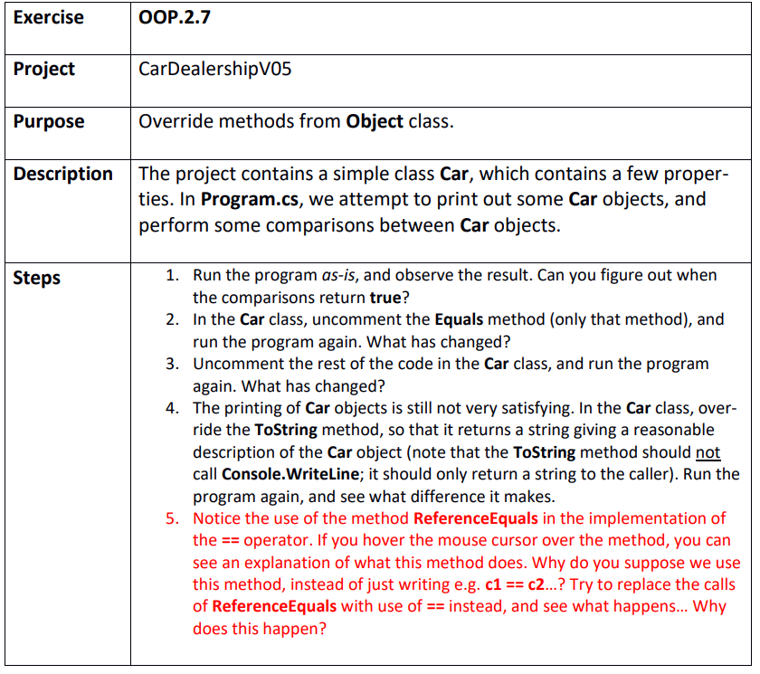

Step 1
CarDealershipV05.sln
When their object reference is the same

Step 2
When their licence plates are the same

Step 3
The == operator has been implemented with the same logic as the Equals method

Step 4
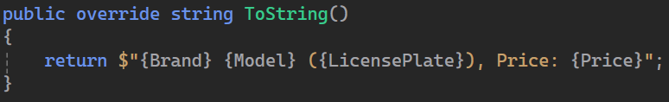

Step 5
If we use == inside of the == operator between the two cars we will get infinite recursion because the operator calls itself. We can however use licenseplate == licenceplate since that is another implementation of == operator outside of the scope

